|  |  |
| --- | --- |
| **Ex. No. 6** | **JAVASCRIPT - TIMER FUNCTIONS AND OBJECTS** |
| **Date of Exercise** | 29-8-2022 |
| **Web Host Link** |  |
| **YouTube Link** |  |

**Aim:**

To create web pages using various timer functions, events and objects in JavaScript.

**Description:**

**Timing Events**

The window object allows execution of code at specified time intervals. These time intervals

are called timing events. The three key methods to use with

JavaScript are:

* setTimeout(function, milliseconds)

Executes a function, after waiting specified number of milliseconds.

Ex:window.setTimeout(function,millisecds);

* setInterval(function,milliseconds)

Same as setTimeout(), but repeats the execution of the function

continuously.

Ex: window.setInterval(function, milliseconds);

* The clearInterval() method stops the executions of the function specified in the setInterval() method.

EX: window.clearInterval(timerVariable)

**Date Object**

Date Object gives various methods to multiple ways to access date, month, year details.

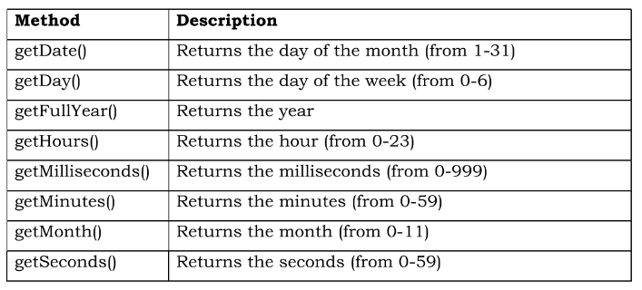

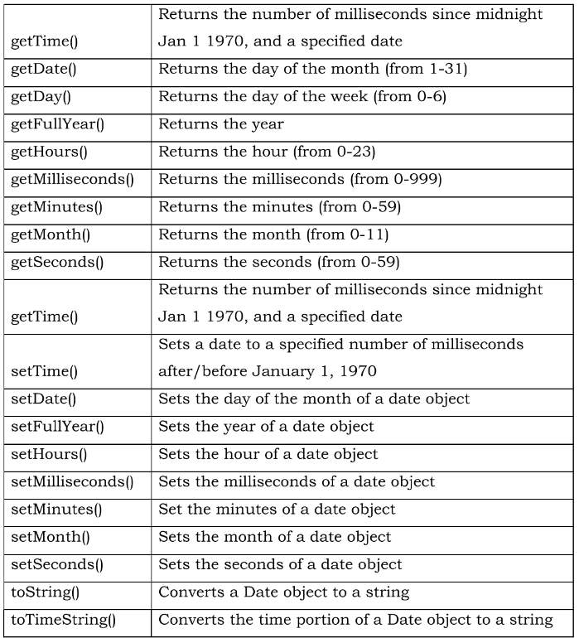

**Class and Object**

A class is a type of function, but instead of using the keyword function to initiate it, we use the keyword class, and the properties is assigned inside a constructor() method.

Example:

class Car {

constructor(brand) {

this.carname = brand;

}

present() {

return "I have a " + this.carname;

}

}

mycar = new Car("Ford");

document.getElementById("demo").innerHTML = mycar.present();

# Program:

1. Write JavaScript code to display digital clock.

**Code:**

<!DOCTYPE html>

<html>

    <head>

        <title>Digital Clock</title>

    </head>

    <body onload="display()">

        <h1>Digital Clock</h1>

        <p id="time"></p>

        <script>

            function display()

            {

                const today = new Date();

                let h = today.getHours();

                let m = today.getMinutes();

                let s = today.getSeconds();

                m = checkTime(m);

                s = checkTime(s);

                document.getElementById('time').innerHTML =  h + ":" + m + ":" + s;

                setTimeout(display, 1000);

            }

            function checkTime(i)

            {

                if (i < 10) {i = "0" + i};

                return i;

            }

        </script>

    </body>

</html>

**Output:**

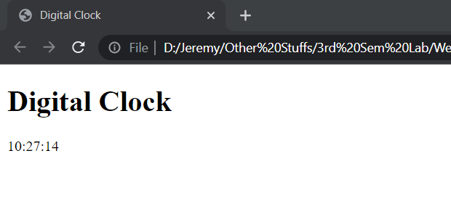

1. Write JavaScript code to change background colour for every 30 seconds.

**Code:**

<!DOCTYPE html>

<html>

    <head>

        <title>BG Color changer</title>

    </head>

    <body onload="color()">

        <h1>Dynamic Background!</h1>

        <script >

            function color()

            {

                var red = Math.floor(Math.random()*255);

                var blue = Math.floor(Math.random()*255);

                var green = Math.floor(Math.random()*255);

                var color = "rgb("+red+","+green+","+blue+")";

                document.getElementsByTagName("body")[0].style = "background-color:"+color;

            }

            setInterval(color,30000);

        </script>

    </body>

</html>

**Output:**

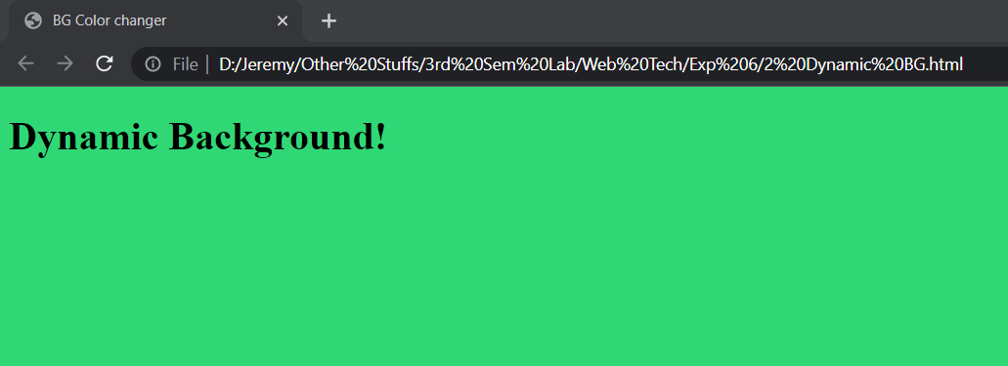

1. Create event handlers that will increase the font size when a mouse moves over a paragraph and decrease the size when the mouse moves off the paragraph.

**Code:**

<!DOCTYPE html>

<html>

    <head>

        <title>Change font size</title>

    </head>

    <body>

        <h1>Change Font size</h1>

        <p id="para1" onmouseover="incSize()" onmouseout="decSize()"> Move cursor over me to zoom in....</p>

        <script>

            function incSize()

            {

                document.getElementById("para1").style = "font-size : 28px";

            }

            function decSize()

            {

                document.getElementById("para1").style = "font-size : auto";

            }

        </script>

    </body>

</html>

**Output:**

**On mouse out:**

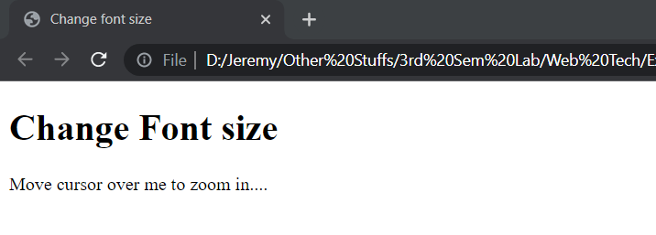

**On mouse over :**

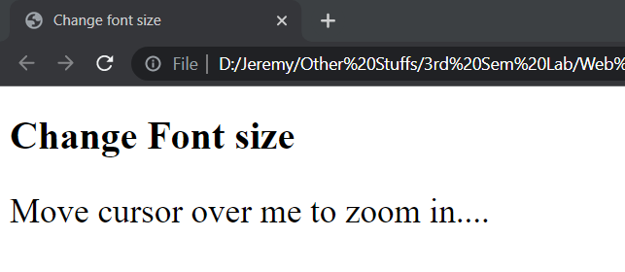

1. Write JavaScript code to move absolutely-positioned car image when a user clicks the move button and stop the car image when a user clicks the stop button on the following webpage.

**Code:**

<!DOCTYPE html>

<html>

    <head>

        <title>Car</title>

    </head>

    <body>

        <h1>Move a Car</h1>

        <button type="button" onclick="moveRight()">Move Right</button>

        <button type="button" onclick="stop()">Stop</button>

        <img id="img" src="car.jpg">

        <script>

            function init()

            {

                imgObj = document.getElementById('img');

                imgObj.style.position = 'relative';

                imgObj.style.left = '0px';

            }

            function moveRight()

            {

                imgObj.style.left = parseInt(imgObj.style.left)+1+'px';

                animate = setTimeout('moveRight()',10);

            }

            function stop()

            {

                clearTimeout(animate);

                imgObj.style.left = '0px'

            }

            window.onload = init()

        </script>

    </body>

</html>

**Output:**

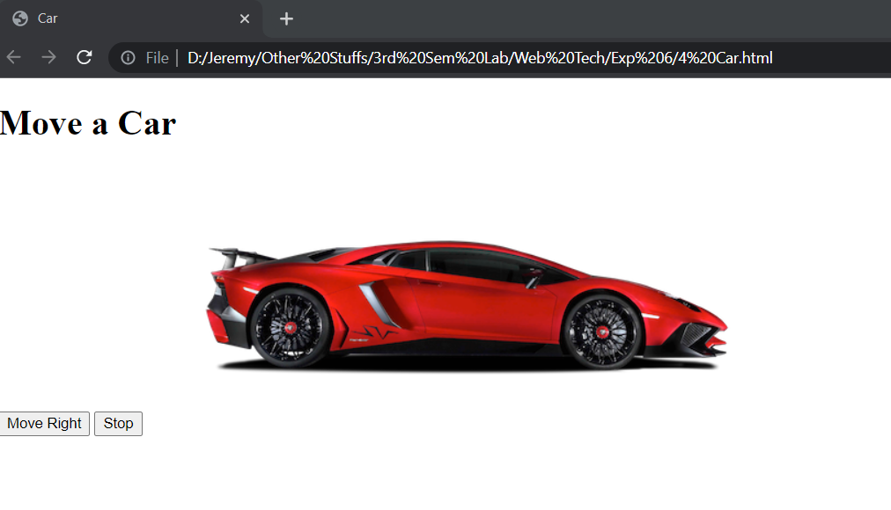

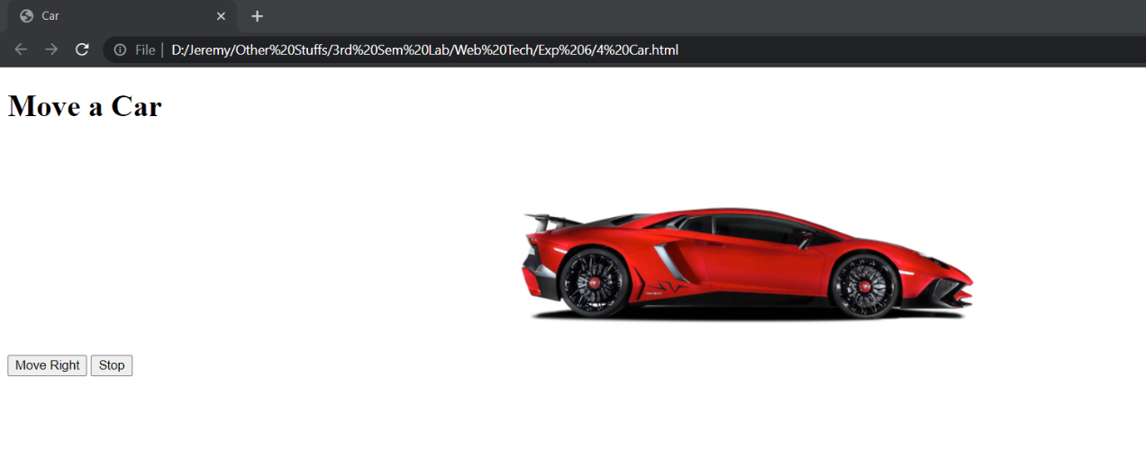

1. Create an array of objects, where each object describes about a student and his/her properties for the name (a string), regno (a string) and year of birth (a number). Iterate through the array of students and display it on the web page. For each student, print the student name and register no like so: "John's Register Number is UR13CS129". Now use an if*/*else statement to categorize the students they have date of birth before 2000 and after 2000.

**Code:**

<!DOCTYPE html>

<html>

    <head>

        <title>Student</title>

    </head>

    <body onload="Student_arr()">

        <h1>Student details</h1>

        <div id="out_before"></div>

        <div id="out_after"></div>

        <script>

            function Student_arr()

            {

             var Student = [{name : 'John', r_num : 'URK20CS2028', dob : '20-apr-1995'},{name : 'Joseph',r_num : 'URK20CS2048',dob : '05-jan-1998'},{name : 'Ram',r_num : 'URK20CS2052',dob : '05-jan-2005'}];

                let text_before = " "

                let text_after = " "

                for(var i =0; i<Student.length;i++)

                {

                    let nam = Student[i].name;

                    let reg = Student[i].r_num;

                    let d_o_b = Student[i].dob;

                    dob_slice = d_o_b.slice(7,11);

                    year = parseInt(dob_slice);

                    if(year < 2000)

                    {

                        text_before +=nam + "'s Register Number is " + reg+"<br>";

                    }

                    else if (year > 2000)

                    {

                        text_after +=nam + "'s Register Number is " + reg+"<br>";

                    }

                }

                document.getElementById('out_before').innerHTML ="<b><u>Student have date of birth before 2000</u></b><br>"+ text_before;

                document.getElementById('out_after').innerHTML ="<br><b><u>Student have date of birth after 2000</u></b><br>"+ text_after;

            }

        </script>

    </body>

</html>

**Output:**

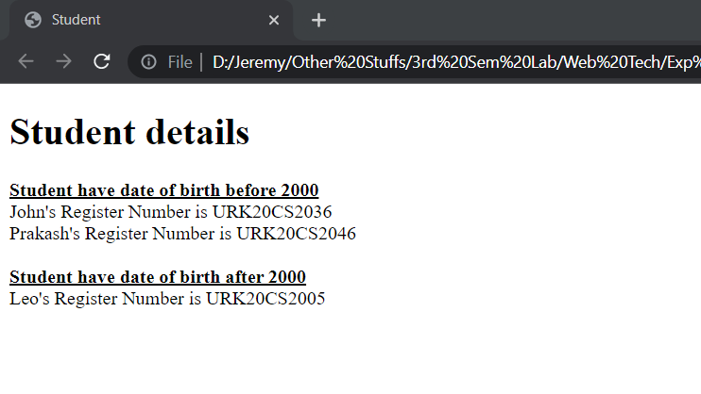

# Result:

The website has been successfully created using JavaScript timer function and objects.